**Deakin University**

Faculty of Business and Law

Deakin Business School

**MAF900 Assessment 3**

**Name:** Chenjia Kristina Li, Stephanie Tio

**Student ID:** 224294027, 223925051

**Unit Chair:** Saikat Deb

20th Oct 2024

## 

Table of Contents

Introduction 3

Results Analyses and Findings 3

Table 1 3

Table 2 3

Table 3 4

Table 4 4

Conclusion 5

**References** 7

Appendix A 8

Appendix B 8

Appendix C 8

Appendix D 8

## 

## Introduction

Based on MAF900, we elaborate on the replicated results and the differences from the article “*Risk, Return, and Equilibrium: Empirical Tests*” in this report, providing analysis insights.

# Results Analyses and Findings

## Table 1

Fama uses samples of all common stocks traded on NYSE from January 1926 to June 1968, total of nine periods. Table 1 shows how the nine periods are constructed, portfolio formation period, initial estimation period, and testing period, including the number of available securities and the number of securities that meet the data requirements. Securities are required to have data available in the first month of the testing period and complete data for the five-year estimation period and at least four years of the formation period.

We calculate the number of securities and create Table 1, extending the sample period to 2023, helps us use more data to test the model. From period 1 to period 7, we get a similar number of securities available. For period 8 and period 9, the number of securities is greater (Fama and Macbeth: 1,162 in period 8; 1,261 in period 9. Kristina and Stephanie: 1,351 in period 8; 1,480 in period 9), due to an update of the data in the CRSP. However, the number of securities meeting data requirements has some discrepancies. On average, Fama and Macbeth get more data than us. Especially in period 1, we have 277 securities meeting their rules compared to 435 securities of the paper. Interestingly, results of period 6 we construct are almost consistent with those in the article, indicating our method is accurate to some extent. The reason for the discrepancies is due to the use of different statistics programs and a total of 22 periods. The number of available securities remain above 2,000 since 1963, and the number of securities that meet the requirements also exceeds 1,000. This is consistent with the trading situation in the securities market

.

## Table 2

Table 2 is to present the key statistics of the portfolios formed by ranking stocks based on their beta estimates, showing how portfolio risk is related to returns and how will betas explain this relationship.

We follow the same approach outlined in their paper, using CRSP monthly stock return data by calculating betas using regression of individual stock returns against the market return (Fisher-Index). Securities are ranked by their betas, allocated into 20 portfolios. We recalculate statistics such as beta, standard deviation, and residual for each portfolio over the second period (initial estimation period, updated annually). Portfolio returns are regressed against market returns during the testing period to generate statistics replicating the methodology in the paper.

According to our results, the values of betas ​​we obtain are slightly different from those in the article due to the extended dataset, which includes more recent market data. Some trends are consistent with the original results. Beta values increase from Portfolio 1 to 20 in our results and Fama’s paper shows the risk-return relationship. The standard errors of betas (s(Beta_p,t-1)) and R-squared values (r(Rp, Rm)^2) are similar with a slight increase in the replication, showing higher market volatility in modern times. The standard deviation of portfolio return (s(Rp)) in the replicated table is marginally higher, due to the inclusions of recent periods marked by significant market fluctuations (such as the 2008 financial crisis).

## Table 3

Table 3 estimates the relationship between portfolio returns and systematic risk through cross-sectional regressions, reports the coefficients from the regressions of portfolio returns on beta. We conduct cross-sectional regressions for each period, using stepwise approach across multiple periods to capture the time-varying nature of these relationships. For each period, we calculate the t-statistics and R-squared values to assess the goodness of fit, aligned with the original paper.

Comparing findings, we find that both show consistent trends, with some differences due to the extended dataset. The gamma coefficients (γ0 and γ1) follow a similar pattern, showing the positive risk-return relationship, our γ1 values (risk premium) are slightly lower in some periods, indicating modern market dynamics. T-statistics for γ1 in our replication are generally significant and slightly lower than in the original paper, which means more uncertainty in the recent data. R-squared values are comparable, showing that beta explains a substantial portion of return variation in both studies. The standard errors of the coefficients in our replication are slightly higher, showing increased market volatility in recent decades.

## Table 4

Similar to the paper, we use cross-sectional regression for each period, estimating coefficients (intercept (γ0), risk premium (γ1), portfolio betas), over the different periods, capturing relationship between returns and risk.

Our approach replicates the process of estimating monthly risk premia and market returns for each portfolio over time. The methodology of calculating and updating portfolio betas, performing regressions for each period, summarising key coefficients is directly aligned with the paper’s methodology.

In Fama’s paper, market return is notably high in 1935-1945. Our replication has the same general trend, during financial crises, market returns are significantly lower, showing market downturns. In a stable period, returns align more closely with those seen in Fama’s study. The risk-free rate in Fama’s study is relatively stable, especially during the earlier periods (1930–1960), it remains low due to more controlled economic policies post-Depression. In our replication, after 2000, risk-free rate declined further, particularly post-2008 when central banks implemented policies (e.g. quantitative easing and near-zero interest rates). The differences reflect the significant policy changes in recent decades, which are not part of the historical periods in Fama's analysis.

Risk premia in the original paper tended to be higher during earlier periods, showing that higher risk is compensated with greater returns in volatile, post-recovery markets. Similarly, our replication, risk premia show a similar pattern, with higher premia in periods of market recovery (e.g. post-2000 dot-com bubble recovery). However, during periods like 2008–2010 and 2020, risk premia are lower, reflecting increased market uncertainty and flight to safer assets during crises. This lower risk premium in recent decades highlights the greater volatility, more risk-averse behaviour in modern markets compared to the historical data in Fama’s study.

In Fama’s analysis, the standard deviations of returns are moderate, with periods of volatility during market downturns (e.g. 1930s). Standard deviations in our replication are generally higher in recent decades. Periods around 2008 and 2020 show volatility compared to the more stable post-war periods reflected in the paper. This higher volatility in modern data introduces more noise and uncertainty into the relationship between risk and return, seen in the wider range of values for market returns and risk premia.

## Conclusion

In conclusion, we replicate the tables from Fama’s paper using an extended dataset up to 2022, following their methodology, portfolio formation, beta estimation, and cross-sectional regression. Our findings aligned core relationships identified in Fama’s paper, such as the positive relationship between risk and return and the significance of beta of portfolio returns.

The differences in the results, particularly higher market volatility, lower risk premia, and declining risk-free rates in recent periods, reflect the impact of modern financial situations and policy changes. These variations highlight the evolving market dynamics while affirming Fama’s approach remains relevant, understanding risk-return relationships for various periods.

## **References**

Fama, E. F., & MacBeth, J. D. (1973). Risk, Return, and Equilibrium: Empirical Tests. *Journal of Political Economy*, *81*(3), 607–636. https://www.jstor.org/stable/1831028

## Appendix A



Figure 1. Overview results of Table 1

## Appendix B

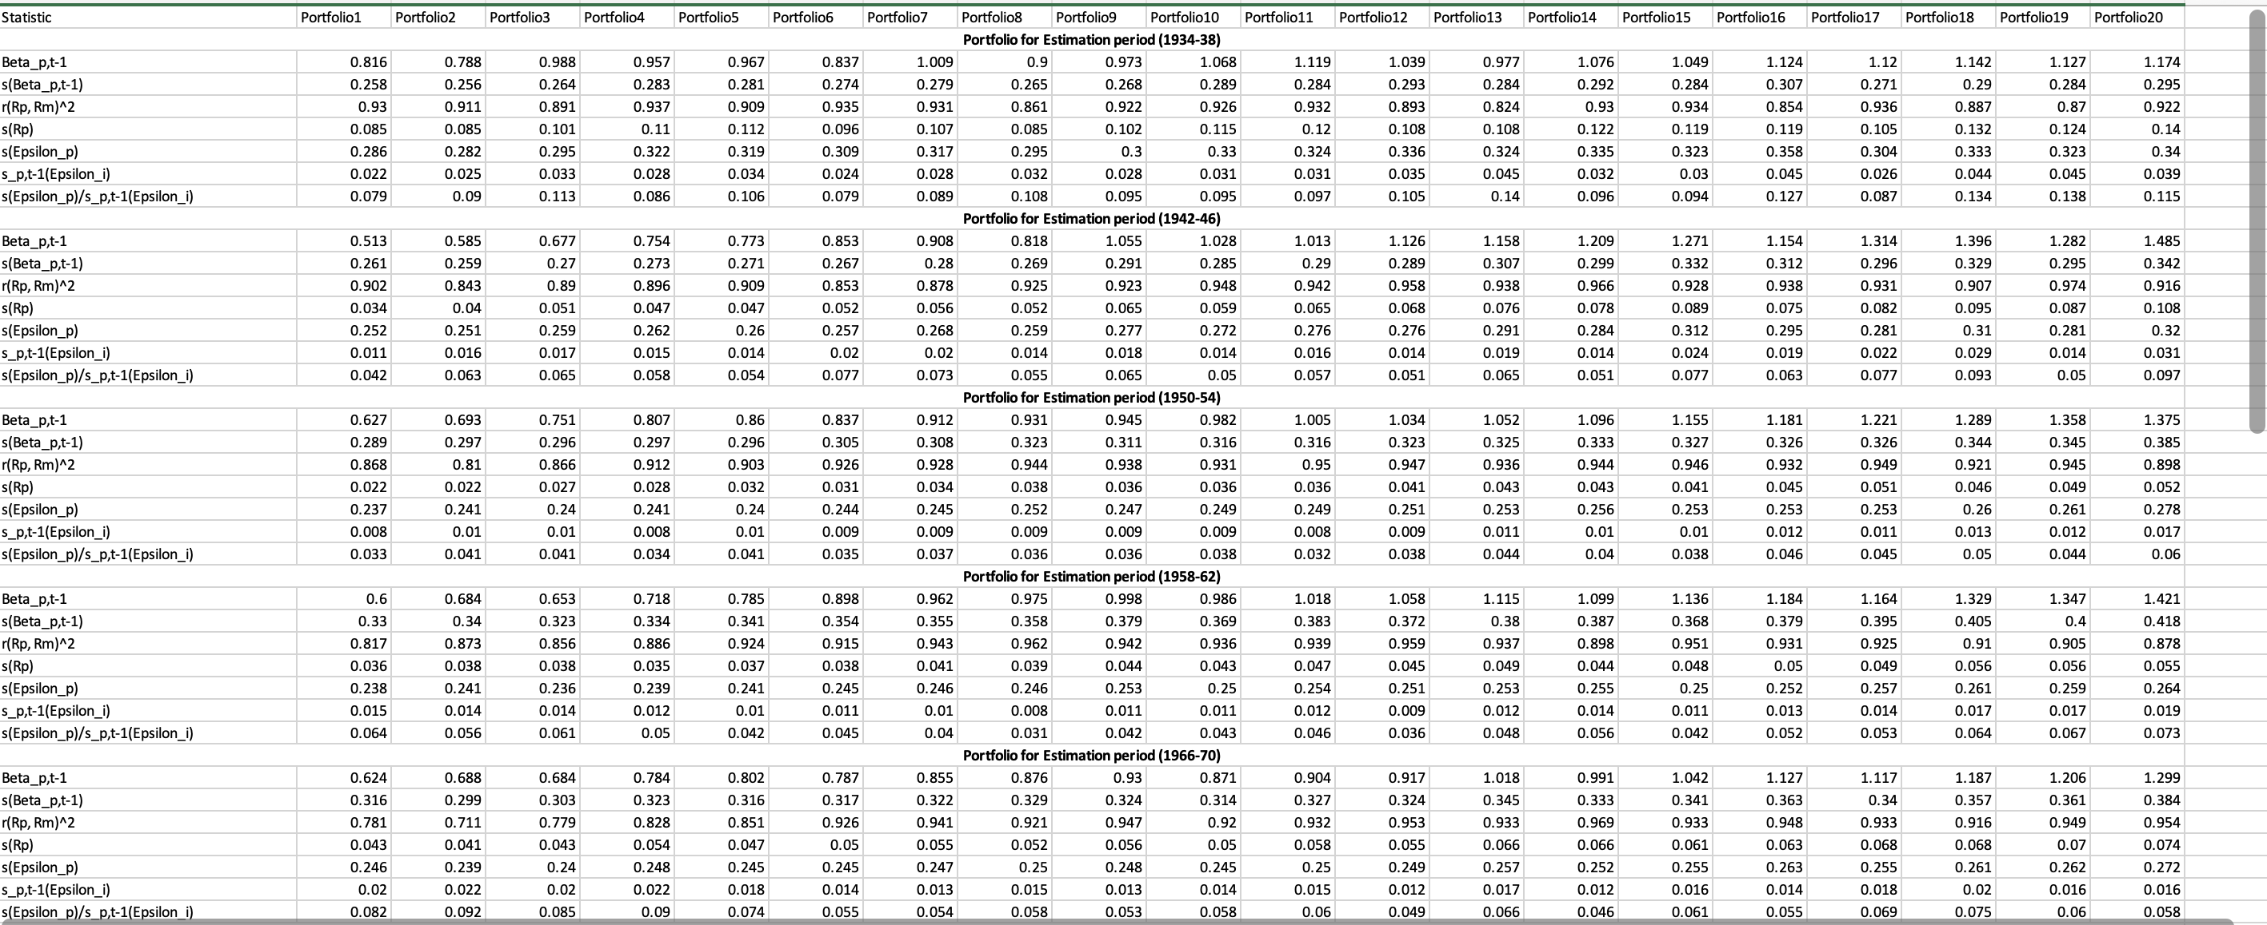

Figure 2. Overview results of Table 2

## Appendix C

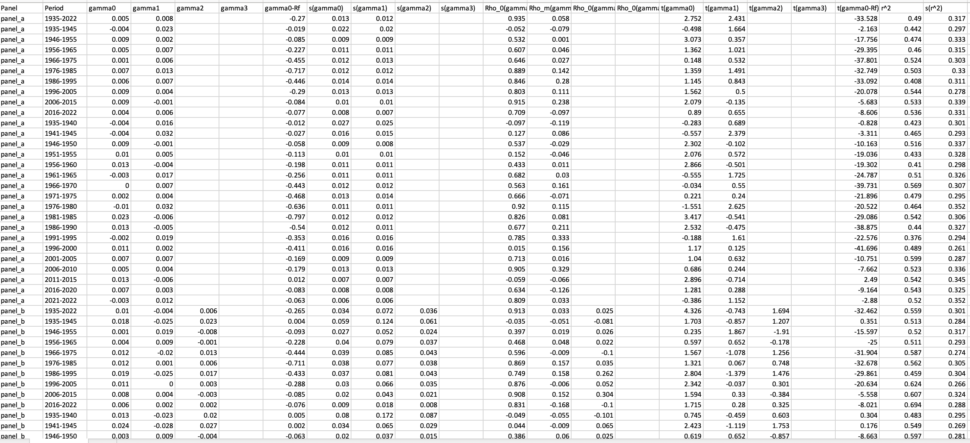

Figure 3. Overview results of Table 3

## Appendix D

Figure 4. Overview results of Table 4